Lesson 6 (2365) - intermediary switch

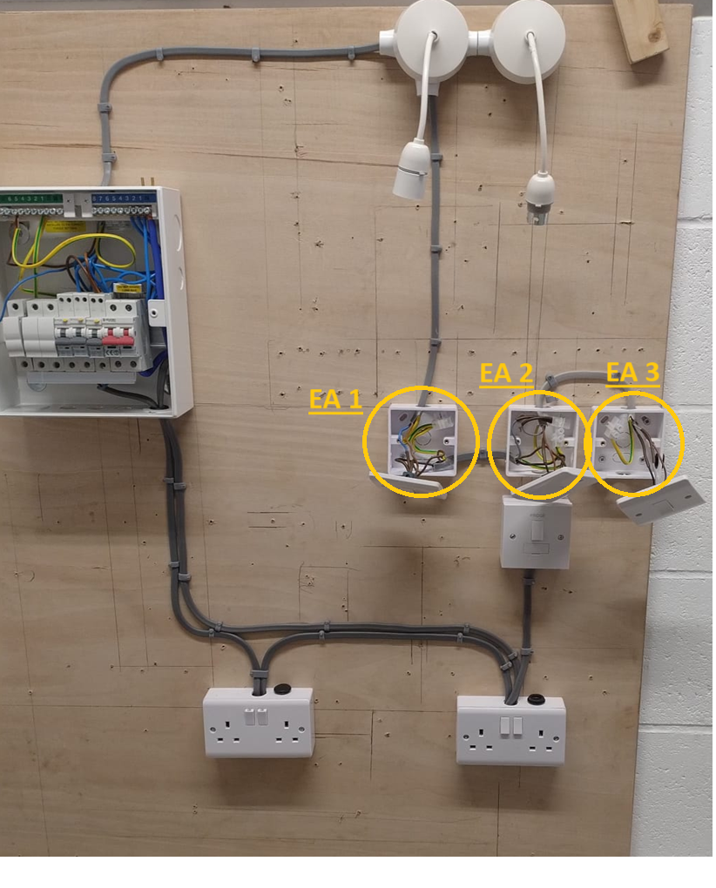

**Practical**

In lesson 6 we added an intermediary switch. Which can be viewed in the diagram below **Electrical Area 2 (EA 2)**.

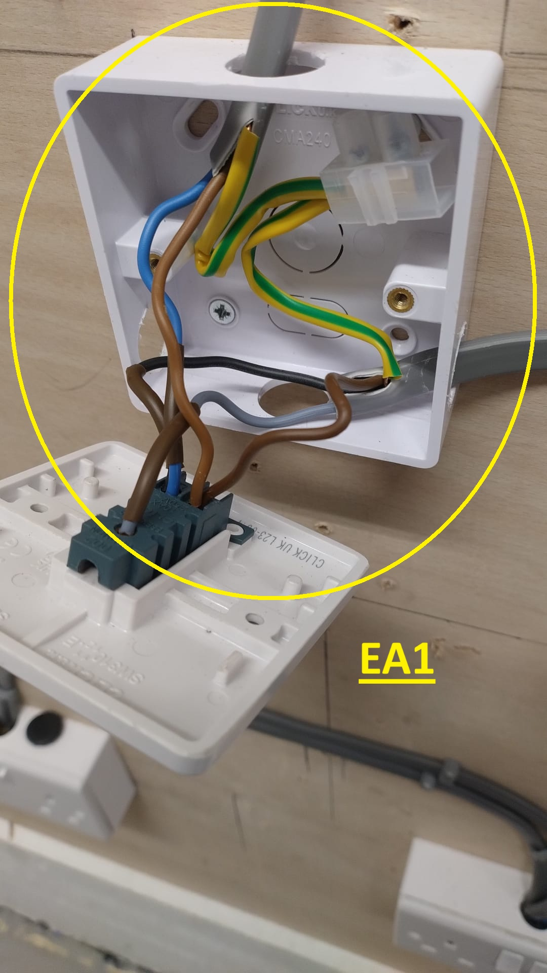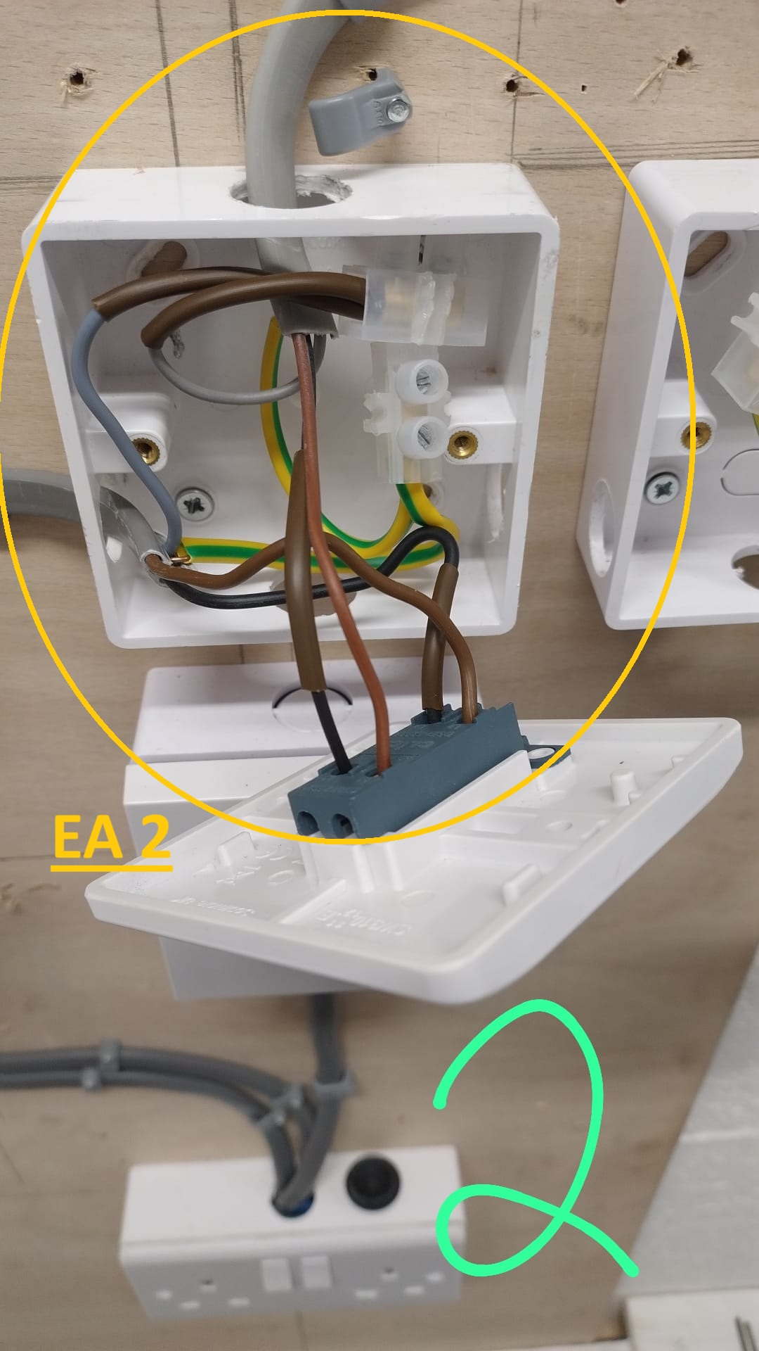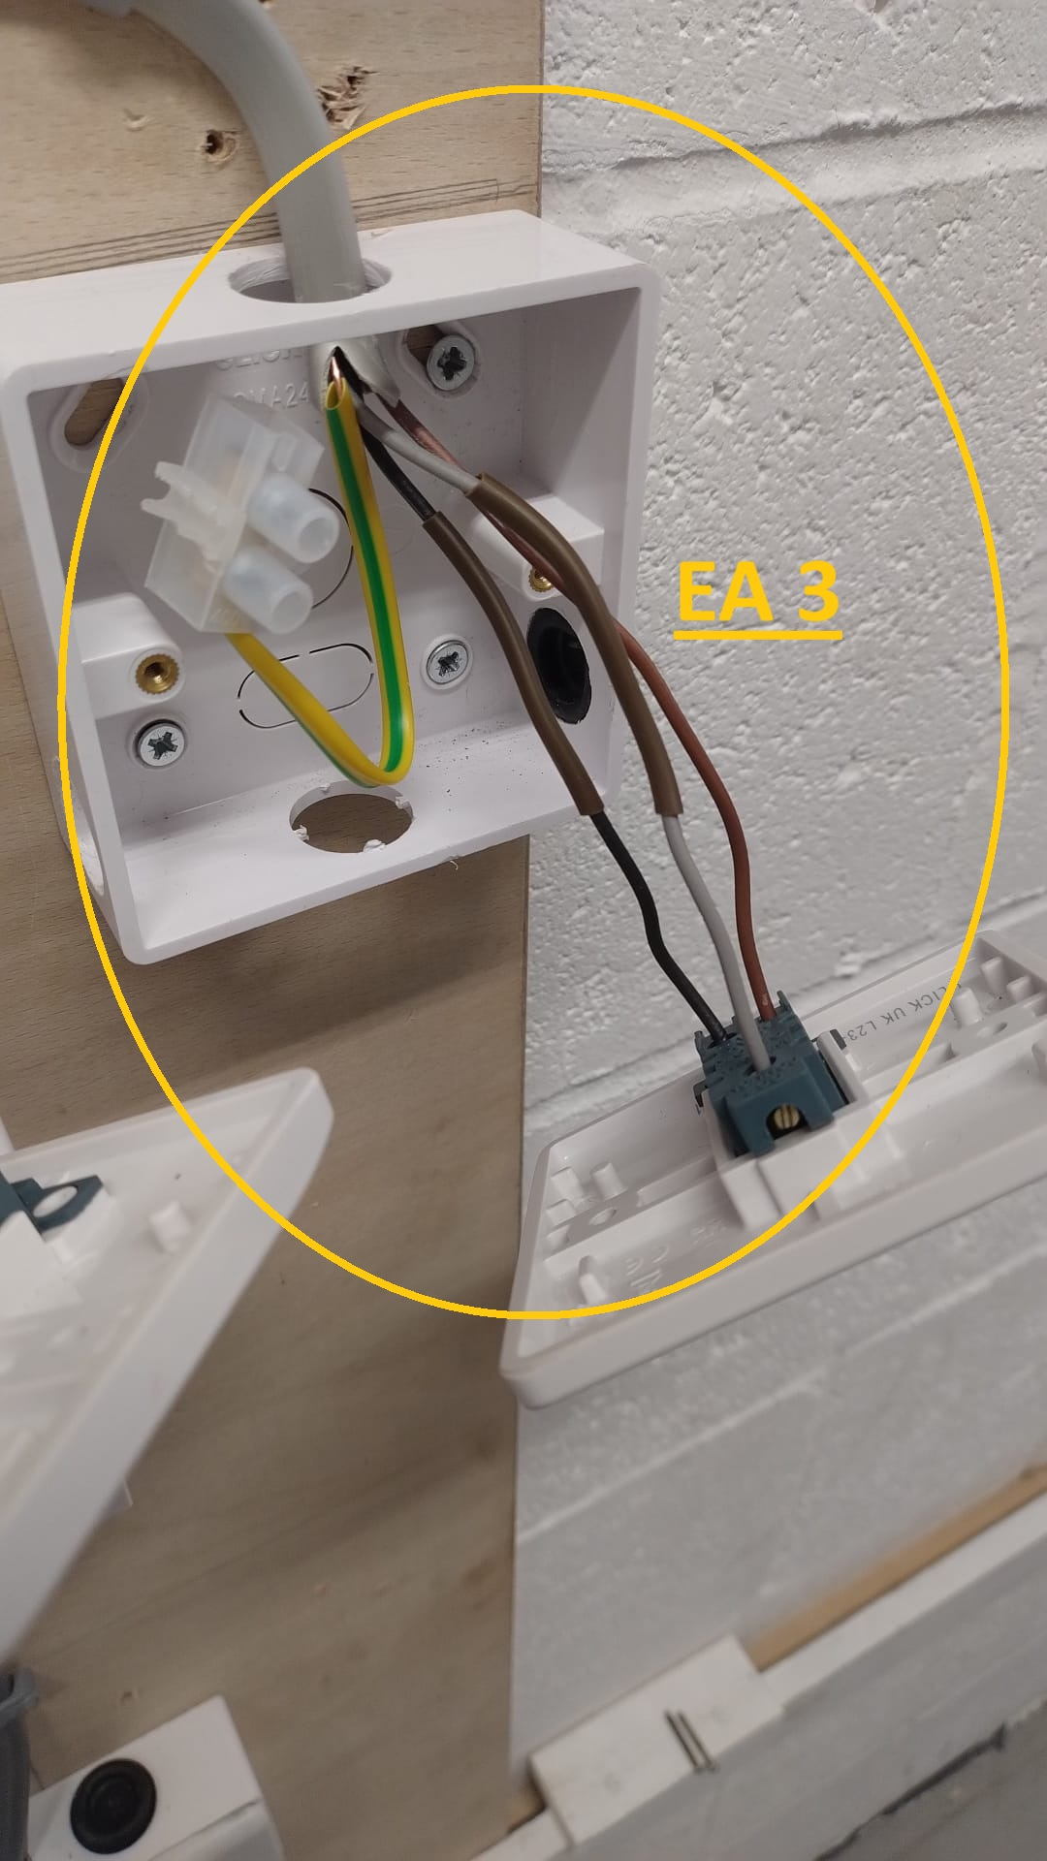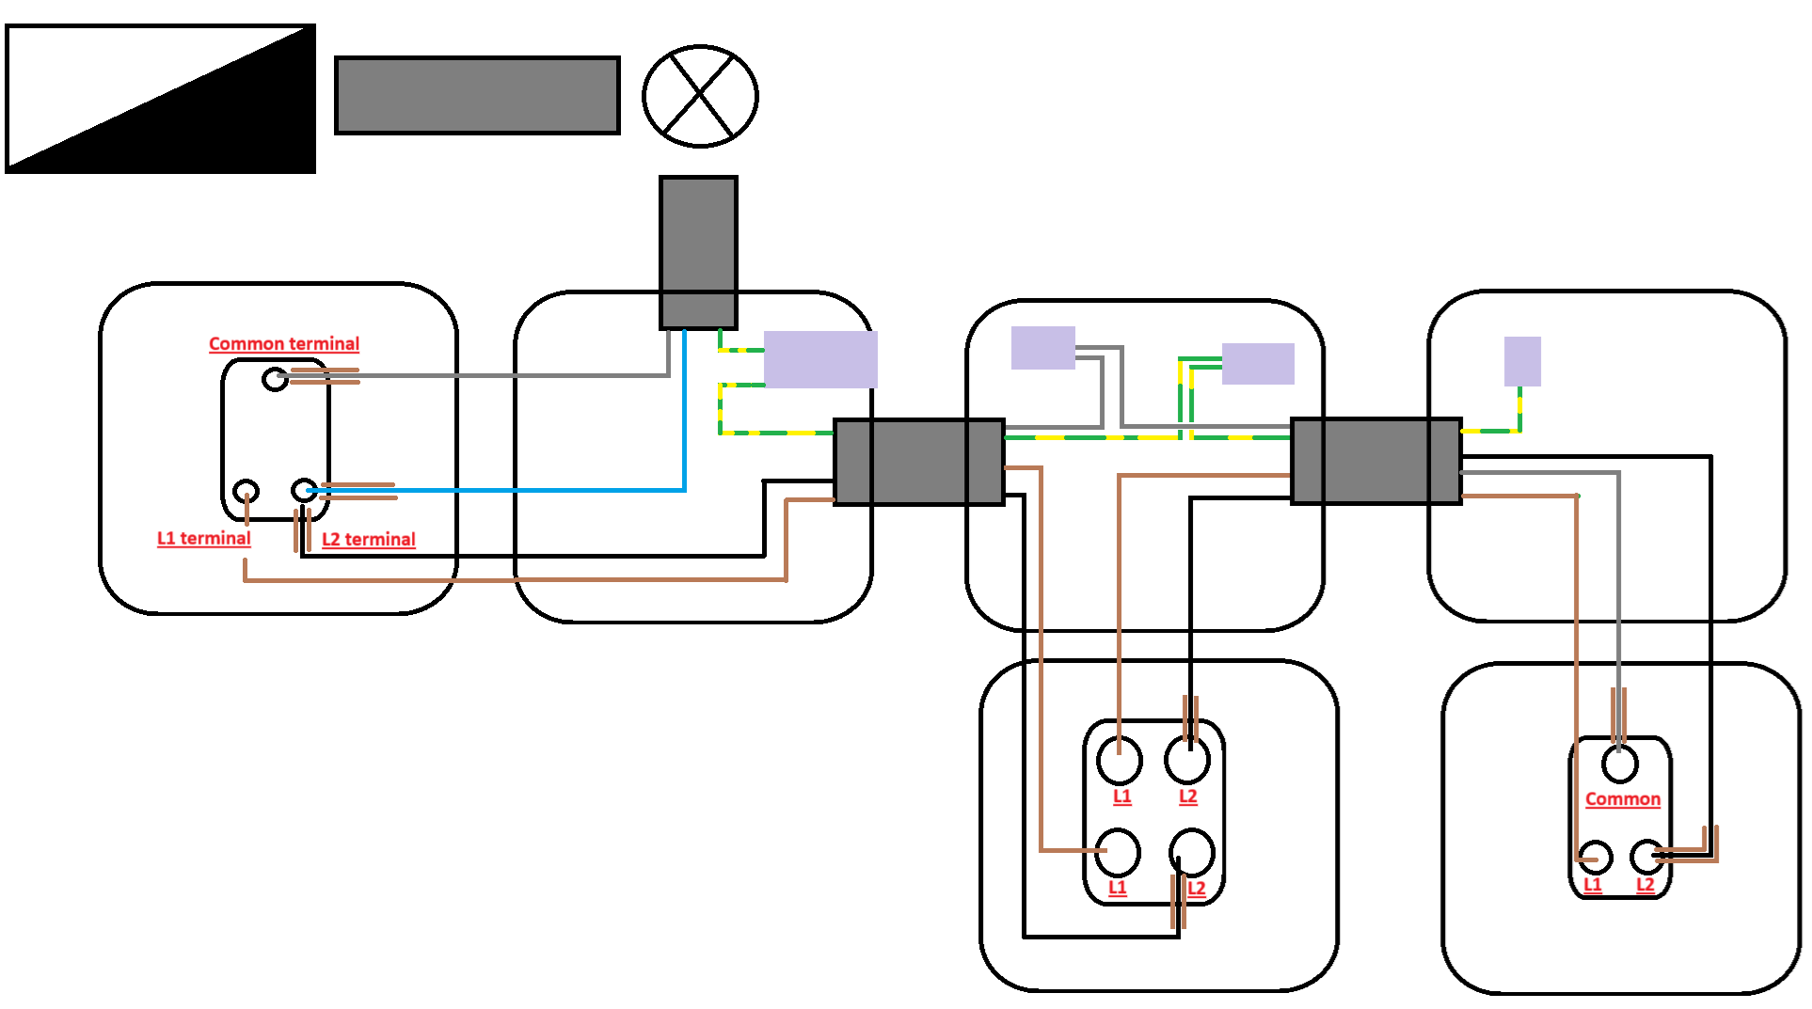

**Electrical wiring diagram**

**Theory**

This class was the first in the module of electrical science. We covered some maths related questions. Such as the calculation of cable sizes.

we also started on the practical of intermediary switches. You can have X number of intermediary switches. However, the first and last switches are wired in the same. In a way, the first and last wire mirror each other. Whereas with all of the intermediary switches the grey switch live cable is place into a connector block.

**Types of diagrams**

Block diagram –

Circuit diagram –

Wiring diagram –

Barchart –

As fit plan – sometimes the trades people cannot adhere to the architectural plan due to unforeseen circumstances. Therefore, the “As fitted plan” captures the adjustments made.

Architectural plan – the plan drawn by the architect.

(Simple) Circuit – schematic – wiring (complicated)